**BUS5001 CLOUD PLATFORMS AND ANALYTICS ASSESSMENT 03 ROBOTIC PROCESS AUTOMATION AND AI IN THE CLOUD**

# Q4. Evaluating Cloud Based Technology

## a) Key Functionalities of NotebookLM for University Academic Activities

Google’s NotebookLM offers several thoughtful and powerful features that align closely with the everyday needs of students, researchers, and lecturers in a university setting. These features are designed to make working with learning materials more interactive, accessible, and efficient. Here are the key functionalities**:**

**1. Smart Summarisation of Documents**

NotebookLM can automatically summarise lengthy academic readings, research papers, or lecture notes into concise overviews. This helps students quickly grasp the main ideas without having to read every single word—saving time during study or revision.

Example*:* A student uploads a 20-page journal article, and NotebookLM instantly provides a paragraph-sized summary of the key points and arguments.

**2. Context-Aware Q&A Assistant**

The built-in AI chatbot allows users to ask specific questions about their uploaded documents. The responses are grounded in the uploaded sources, which helps avoid misinformation and ensures the answers are relevant to the actual content.Example*:* A student can ask, “What are the limitations of the relational data model mentioned in this article?” and receive a direct answer with referenced quotes from their uploaded notes or PDFs.

**3. Timeline Generation**

NotebookLM can structure historical or sequential information—such as the evolution of data storage models or key technological milestones—into a timeline format. This is especially useful for visual learners and for subjects that involve chronological developments.Example: A timeline showing the progression from flat files in the 1960s to modern NoSQL databases helps clarify complex topics with ease.

**4. Study Guide and Quiz Builder**

The assistant can generate a personalised study guide with practice questions based on the uploaded materials. This supports active recall—a technique proven to improve learning retention.Example*:* From a lecture on Cloud Computing, NotebookLM can generate a question like: “Explain the difference between object storage and block storage,” helping the student prep for exams.

**5. Briefing Documents and FAQ Generation**

NotebookLM can produce briefing documents or FAQs summarising the uploaded content. These are useful for both students revising for exams and lecturers preparing overviews for class.Example*:* A lecturer uploads multiple research articles and uses the briefing feature to generate a concise summary of the main themes to introduce in a seminar.

**In Summary:**

NotebookLM transforms static study materials into dynamic learning experiences. It acts as a study companion that helps users understand content more deeply, revise more effectively, and stay organized—all without needing advanced technical skills. It’s a promising tool for enhancing academic productivity in a university environment.

**Q4(b) – Application of NotebookLM Features in a Real Academic Scenario**

Course Context: *BUS5001 – Cloud Platforms and Analytics*  
Tool Evaluated: Google Notebook LM

As part of the BUS5001 unit, I uploaded lecture materials (in PDF format) from the LMS into Google’s Notebook LM, an AI-powered educational assistant. The purpose was to explore how this tool could support exam preparation, enhance comprehension of technical content, and streamline study routines. Below is a demonstration of how each of Notebook LM’s core features was applied within this real academic scenario.

## B. Demonstration of NotebookLM Features in an Academic Scenario

As part of my learning in *BUS5001 - Cloud Platforms and Analytics*, I uploaded lecture materials from my LMS into **NotebookLM** to assist with exam preparation. Below is a feature-wise breakdown of how I used each tool, along with its usefulness in my academic work.

**1. Chatbot**   
During my preparation for the BUS5001 exam, I used the NotebookLM chatbot to interactively understand complex topics from my lecture notes. By uploading the materials directly from the LMS, I could ask specific questions and receive answers tailored to my course content. For instance, when I asked *"What are ACID properties in databases?"*, the chatbot explained that ACID refers to Atomicity, Consistency, Isolation, and Durability—principles that ensure reliable database transactions. It further broke down each term in a simplified way, helping me understand its importance in data integrity. Another example was when I asked *"What is the difference between hierarchical and relational data models?"*, and the chatbot clearly outlined the differences, noting that hierarchical models use a parent-child structure, while relational models are more flexible and use tables connected by keys. All responses were directly referenced from the uploaded lecture materials, ensuring relevance and accuracy.

Why it was useful:  
The chatbot feature was extremely helpful because it saved significant time that I would have otherwise spent manually searching through lengthy lecture slides. Instead of reading through entire PDFs, I could get quick answers to specific questions. It provided clear, syllabus-aligned explanations that matched my academic needs and learning outcomes. Most importantly, it felt like having a personal tutor who was trained solely on my course materials, which made the learning experience more interactive, efficient, and tailored to my university assessments. 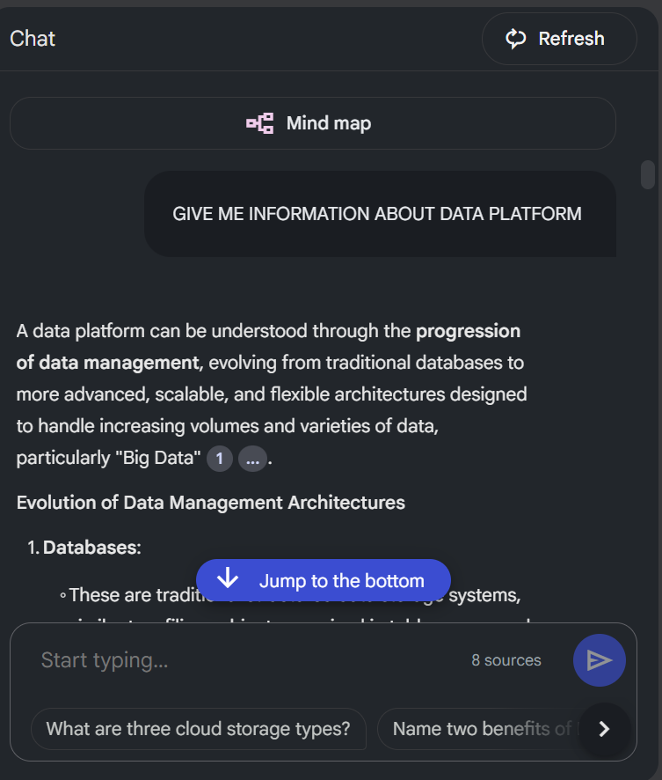

**2. Study Guide – Demonstration:**  
The Study Guide feature of NotebookLM was particularly helpful during my revision for BUS5001. After uploading my lecture notes from the LMS, this tool automatically analysed and summarised lengthy and content-heavy documents into concise bullet points under simplified headings. For example, a detailed lecture on the *evolution of data storage systems* was broken down into a clear, logical flow: starting from Flat Files, moving to Hierarchical Models, then to Relational Databases, and finally to NoSQL systems. This structural breakdown helped me quickly grasp the progression of technologies without having to read through 20 or more slides. The tool also highlighted key definitions and concepts within each topic, presenting them in an organised and easily digestible format.

**Why it was useful:**  
The Study Guide was extremely useful because it allowed me to prioritise the most important content for revision. Instead of reviewing entire lecture files, I could focus on the key points that were more likely to be examined. The ability to condense large volumes of information into just one or two pages made my revision process significantly faster and more efficient. This was particularly beneficial during the final days before the exam, when time was limited and memory recall was critical. Overall, the Study Guide function acted as a customised, AI-generated summary sheet that enhanced both understanding and retention.

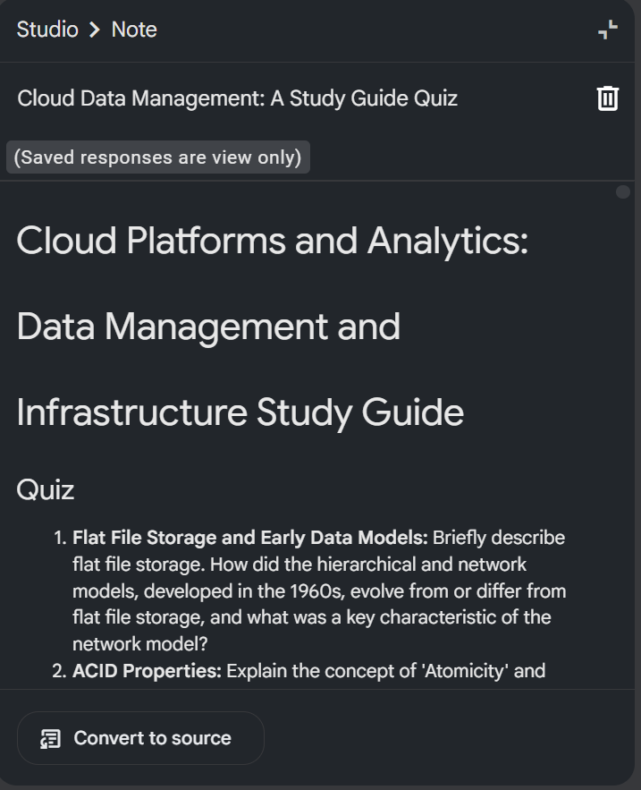

**3. Timeline – Demonstration:**  
The Timeline feature in NotebookLM helped me visualise the chronological development of data management systems covered in my BUS5001 lectures. After uploading my course materials, the tool automatically generated a structured timeline outlining key historical milestones. For instance, it began with the introduction of **Flat File Systems in the 1960s**, followed by the development of **Hierarchical Models by IBM**, then the **Network Model proposed by CODASYL**, and later the groundbreaking **Relational Model introduced by Edgar F. Codd in the 1970s**. It also marked the emergence of **NoSQL databases in 1998**, introduced by Carlo Strozzi to address the limitations of traditional models in handling large-scale, unstructured data. This timeline provided a linear flow of how data storage and retrieval systems evolved over time, making it easier to understand the context of modern data platforms.

**Why it was useful:**  
The Timeline feature was particularly beneficial in helping me retain historical and technical information that is often difficult to memorise. It transformed scattered facts across multiple slides into a cohesive visual sequence. This was especially useful for theory-based exam questions or assignments requiring discussion of technological progression. Instead of just memorising definitions, I was able to understand how each model built upon its predecessor and why newer systems emerged. It supported both comprehension and recall, making it an effective study tool for subjects that involve historical and conceptual development. 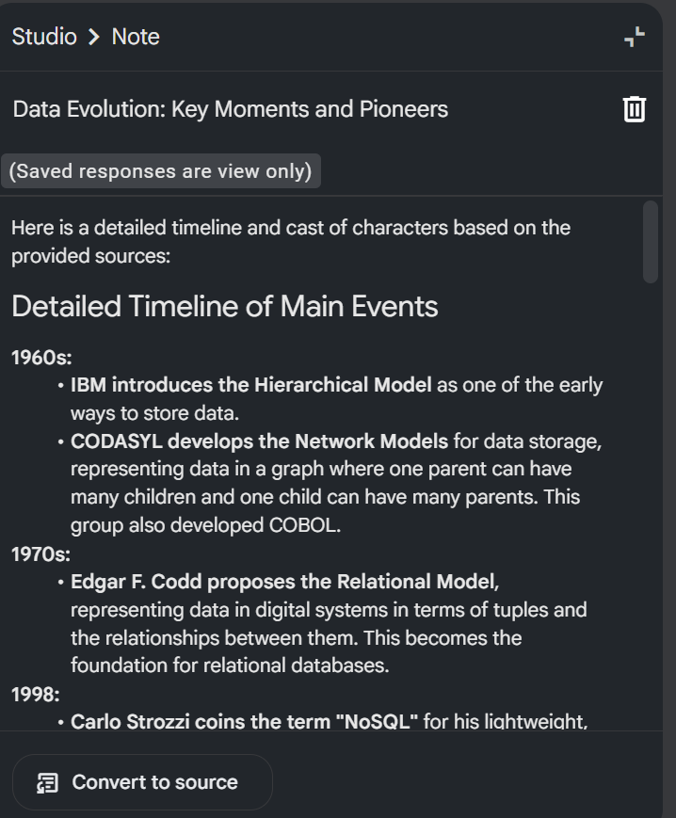

**4. FAQ – Demonstration:**  
The FAQ feature in NotebookLM automatically generated a list of commonly asked questions based on the content of my uploaded BUS5001 lecture notes. Once the materials were processed, the system identified key themes and anticipated what a student might naturally ask while reviewing the content. For example, it created questions like *“What are the limitations of flat file systems?”*, *“Why are relational databases preferred in structured data environments?”*, and *“What is the main difference between ACID and BASE models?”* Each question came with a concise and accurate answer, directly pulled from the uploaded lecture materials. These AI-generated FAQs covered both fundamental and complex topics, giving me immediate clarity on the areas that are most likely to appear in quizzes or exams.

**Why it was useful:**  
This feature was particularly useful because it allowed me to revise in a more interactive and engaging way. Instead of passively reading, I could test myself by going through the list of frequently asked questions and evaluating my understanding of each topic. It also helped reinforce important concepts without the need to search manually through dense lecture slides. By mimicking the type of questions that might appear in real assessments, the FAQ tool functioned like a personalised revision sheet, helping me focus on the most examinable content while identifying gaps in my knowledge.

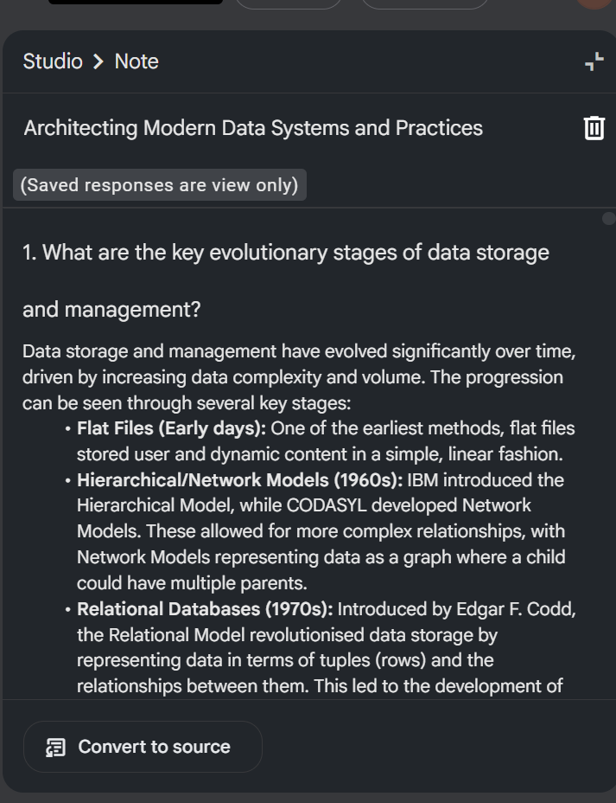

**5. Briefing Document – Demonstration:**  
The Briefing Document feature in NotebookLM was especially valuable when I needed an overview of broader concepts across multiple lecture files. After uploading several BUS5001 lecture notes covering topics such as data platforms, cloud architecture, analytics tools, and storage models, NotebookLM automatically generated a coherent summary that connected the key ideas from all sources. For example, it compiled information about the progression from traditional data storage methods to cloud-based systems, integrated definitions of tools like AWS Glue and Azure Synapse, and highlighted the relationship between big data characteristics and analytics models. Rather than presenting isolated facts, the briefing note grouped related themes and presented them in a structured narrative format, ideal for understanding how different course topics relate to each other.

**Why it was useful:**  
This feature was extremely helpful in building a big-picture understanding of the subject. Instead of reading separate slides and trying to mentally link concepts, the Briefing Document gave me a ready-made summary that tied everything together. It was especially useful for preparing for assignments or short-answer questions that required synthesis rather than memorisation. By providing an integrated view of the subject matter, it saved time, reduced confusion, and helped me understand not just *what* each topic was about, but *how* and *why* they connect in the broader context of cloud platforms and analytics.

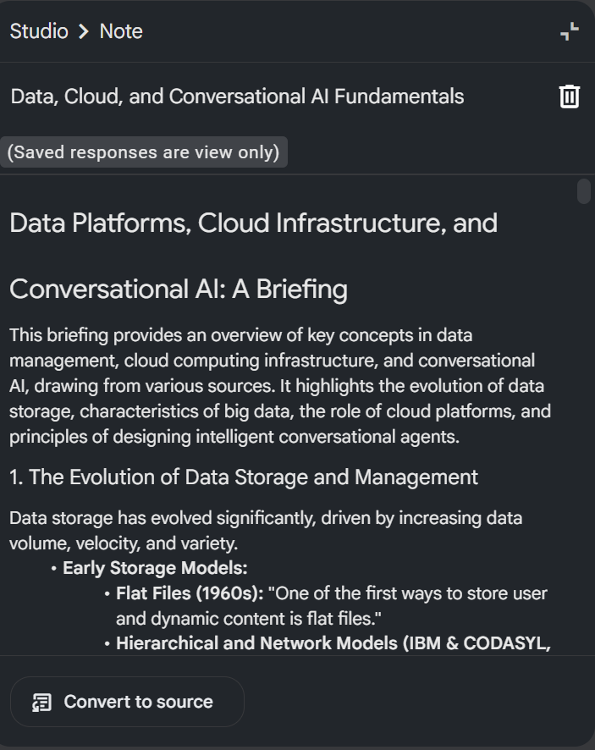

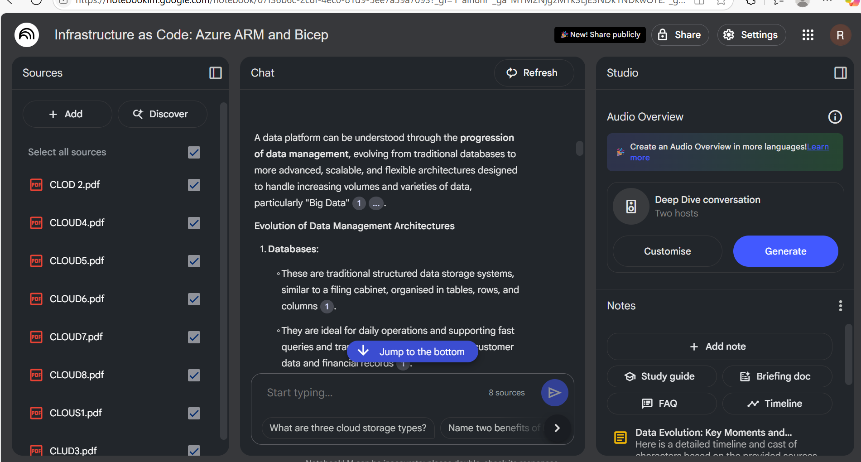

## c. Critical Analysis of NotebookLM Capabilities

**i. Accuracy and Relevance of the AI-Generated Output**

NotebookLM generally produces accurate and contextually relevant output when it is working with clear, structured, and well-written academic materials. Since the tool is designed to generate answers and summaries **based solely on the content uploaded by the user**, it performs well in maintaining relevance to the subject. For instance, when I uploaded my BUS5001 lecture notes, the AI-generated answers on topics such as ACID properties, NoSQL, and data models closely mirrored the course content. It accurately recognised key terms and explained them using the same definitions and examples found in the slides. However, the accuracy depends heavily on the quality of the input material. If the notes are vague or contain outdated information, the AI’s output may reflect those same limitations.

**ii. Usefulness in Academic Workflows**

NotebookLM significantly enhances academic workflows by simplifying study and revision processes. It allows students to interact with their own lecture notes in a dynamic way—through features like chatbot interaction, auto-generated FAQs, summarised study guides, and timeline visualisations. These tools help in various academic tasks such as understanding complex theories, preparing for exams, writing research summaries, and even brainstorming for assignments. The ability to ask questions and get answers based specifically on one’s course materials reduces reliance on external sources and aligns directly with curriculum needs. This personalised and on-demand assistance makes it an effective supplement to traditional studying, especially for time-constrained students.

**iii. Limitations or Concerns – Hallucination, Bias, and Source Transparency**

Despite its strengths, NotebookLM has several limitations. One major concern is **AI hallucination**, where the model may generate information that appears plausible but is not present in the uploaded documents. For example, it might create definitions or historical dates that are inferred incorrectly or not supported by the original content. Another issue is **bias**, especially when the input material overrepresents certain topics. The AI may unintentionally emphasise frequently mentioned terms while ignoring less-repeated but equally important ones. Additionally, **source transparency** can be limited; while the tool references uploaded content, it doesn’t always cite exact page numbers or document locations, which makes it difficult to verify facts for academic writing. This lack of clear traceability could be problematic for high-stakes research or formal referencing.

**Conclusion**

While NotebookLM is a powerful tool that enhances learning through summarisation, interactive questioning, and content mapping, it is important to use it with a critical mindset. Students and researchers should always verify the information against the original materials and not rely entirely on AI-generated responses. With cautious and informed use, the tool can greatly improve comprehension, efficiency, and engagement in academic workflows.